http://www.salidzini.lv/
(6) EuroStore.lv

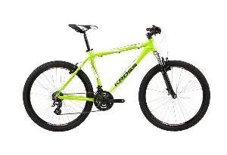

Kross Hexagon V3 M21

160.00 Ls

BMX, Street, Dirt
(2) BaltSport.lv
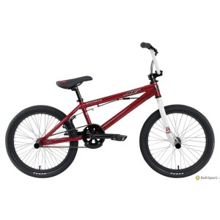

SE Bikes Wildman

160.00 Ls

Velosports >> Velosipēdi >> BMX
(18) Memo.lv
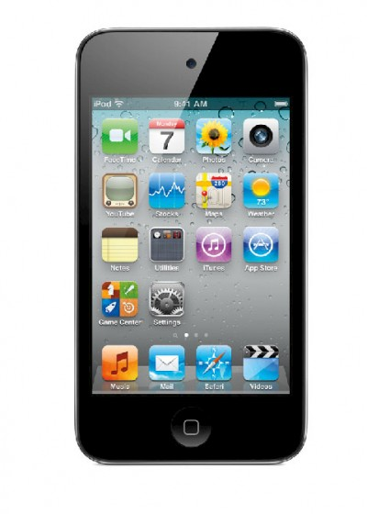

MP3 PLAYER IPOD TOUCH 8GB/4TH GEN MC540 APPLE

153.30 Ls

Foto & Video, Auto GPS MP3, MP4 atskaņotāji
Top of Form

Mobilie telefoni -> iPod -> Apple iPad 16GB WiFi
Apple iPad 16GB WiFi 280.00Ls

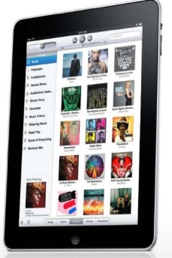
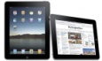
Cena: 280.00 Ls

